Project Design Phase-II Technology Stack (Architecture & Stack)

Date | 02  November 2025
Team ID | NM2025TMID00163
Project Name | Laptop Request Catalog Item
Maximum Marks | 4 Marks

Technical Architecture:
The deliverable includes the architectural diagram and supporting details in Table 1 and Table 2.
This architecture represents how the Laptop Request Catalog Item in ServiceNow enables employees to request laptops efficiently through an automated workflow.
Example: Laptop Request Catalog Item
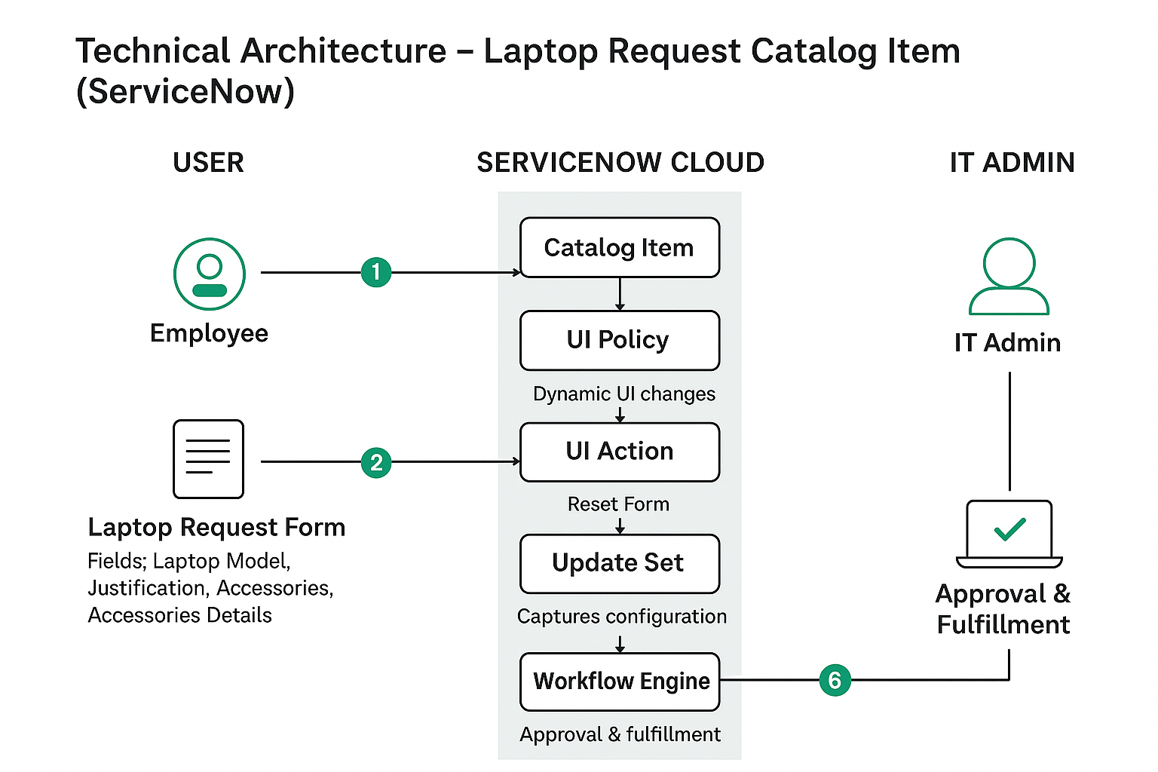
Guidelines:
- Include all ServiceNow processes (catalog item creation, UI policy, UI action, update set).
- Show infrastructure separation — Local Instance and Cloud Instance.
- Indicate external interfaces (email approvals, notifications).
- Highlight data storage in the ServiceNow database.
- Represent automation scripts for dynamic form behavior.
- Show deployment flow of update sets between instances.

Table-1 : Components & Technologies:

S.No | Component | Description | Technology
1 | User Interface | Employees submit laptop requests through the Service Catalog form in ServiceNow. | ServiceNow Service Catalog UI
2 | Application Logic-1 | Handles creation of the catalog item and captures all request variables. | ServiceNow Catalog Item Configuration
3 | Application Logic-2 | Applies dynamic visibility and mandatory rules (e.g., “Accessories Details” field). | Catalog UI Policy, Client Script
4 | Application Logic-3 | Allows users to reset the form using a custom UI Action script. | JavaScript (Client-side)
5 | Database | Stores catalog item details, variable values, and user submissions. | ServiceNow Tables (sc_cat_item, sc_item_option, sc_request)
6 | Cloud Database | Maintains data securely in the ServiceNow cloud environment. | ServiceNow Cloud Database
7 | File Storage | Stores update set XML files for migration across instances. | Internal ServiceNow File Storage
8 | External API-1 | (Optional) Email notification or approval integration. | ServiceNow Notification API
9 | External API-2 | (Optional) Integration with asset management for tracking laptop inventory. | REST API in ServiceNow
10 | Machine Learning Model | Not applicable for current project. | –
11 | Infrastructure (Server / Cloud) | Hosted and managed fully on the ServiceNow SaaS platform. | ServiceNow Cloud (SaaS)

Table-2: Application Characteristics:

S.No | Characteristics | Description | Technology
1 | Open-Source Frameworks | Not applicable, as ServiceNow is a proprietary low-code platform. | –
2 | Security Implementations | Role-based access ensures only authorized users can create, approve, or manage laptop requests. | Role-Based Access Control (RBAC), ACLs
3 | Scalable Architecture | Built on ServiceNow’s SaaS model, allowing easy scalability across departments and instances. | ServiceNow Cloud Architecture
4 | Availability | Always accessible via the ServiceNow cloud, ensuring 24/7 uptime and redundancy. | Load-balanced ServiceNow Instances
5 | Performance | Efficient performance through optimized catalog forms, client scripts, and indexed data tables. | GlideRecord, Service Catalog Optimization

